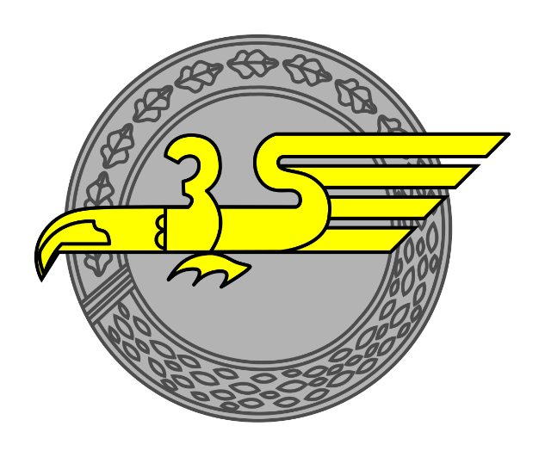

3rd Fallshcirmjäger Division in Normandy, June – August 1944
3rd Fallshcirmjäger Division received a significant number of light automatic weapons before the Normandy landings, including StG44s. However, they did have a smaller number of MGs available, generally only fielding one per section. The division was in a stronger position compared to other Fallshcirmjäger divisions as they had a large number of veterans to lead their platoons and sections, proving them to be tough opponents for the US forces in their sector. One US commander regarded them as “the best damned soldiers I ever saw”. The greater number of automatic weapons 3rd Fallshcirmjäger Division had made them well suited to defence within the bocage country inflicting heavy losses to Allied forces. Their success was short lived as they were nearly destroyed from mass aerial bombing in the Falaise area in August 1944 before being re-formed in Belgium. They would next see action in the Netherlands during Operation Market Garden. This platoon is based on historical documents and represents one example of a different platoon TOE. The initial regular platoon is rated for fighting in and around Normandy until August 1944 where they fought against US forces.
Platoon Force Rating: Regular, +6
Command Dice: 5 with Red dice
Force Morale | 1 | 2 | 3 | 4 | 5+
Command Dice | 2 | 3 | 4 | 4 | 5

Platoon Headquarters
Leutnant, Senior Leader with Machine-pistol
Unterfeldwebel, Senior Leader with Assault Rifle (Stg44)

Section One and Two
Obergefreiter, Junior Leader with Machine-pistol, 2 Panzerfaust 30s
MG team | Assault Group
MG34 or MG42  3 Crew | 1 SMG
MG34 or MG42  3 Crew | 1 Automatic Rifle (FG42)
MG34 or MG42  3 Crew | 1 Assault Rifle (StG 44)
MG34 or MG42  3 Crew | 3 Rifles

Section Three
Obergefreiter, Junior Leader with Machine-pistol, 2 Panzerfaust 30s
MG team | Assault Group
MG34 or MG42  3 Crew | 1 SMG
MG34 or MG42  3 Crew | 1 Automatic Rifle (FG42)
MG34 or MG42  3 Crew | 1 Assault Rifle (StG44)
MG34 or MG42  3 Crew | 2 Rifles
MG34 or MG42  3 Crew | 1 Rifle with AT grenade launcher

Regular 3rd Fallshcirmjäger Division platoons are aggressive in close combat

Support
When choosing support options 3rd Fallshcirmjäger Division Platoons choose from the standard German Support list in the CoC rulebook, with the following additions that can only be taken by them.
Support list additions:
One Support Point
1 StG44 to replace 1 Rifle once per section
Two Support Points
sPzB 41 light anti-tank gun, Team with 2 Crew
Three Support Points
Leichtgeschütz 40, Team with 3 Crew
Five Support Points
Leichtgeschütz 42, Team with 3 Crew

Additional Equipment Arsenal Table
Infantry Weapons
Weapon | Range | A.P.
AT Rifle Grenade | 12”-48” | 3

Anti-Tank Guns & Infantry Guns
Weapon | A.P. | H.E. | Size
sPzB 41 | 5 | 2 | Light
Leichtgeschütz 40 | 6 | 6 | Light
Leichtgeschütz 42 | 10 | 8 | Medium

sPzB 41
Whilst the sPzB 41 was primarily used in an anti-armour role, it did have a limited number of HE ammunition available to it. The HE ammunition was however extremely poor with very little explosive charge. It carries only 3 rounds of HE and does not gain the storm of steel bonus or reduce cover by one level when firing HE.
Leichtgeschütz 40/42
Both weapons were primarily intended as artillery support for lighter troops. As such they were not primarily employed in an anti-tank role. To reflect this, both variants only carry a limited ammunition pool of 3 AP rounds.
AT Rifle Grenades
AT Rifle Grenades fire as normal rifle grenades found in the master arsenal table but are only fired at vehicles. They have a limited ammunition of 3 rounds.

Important Note:
We are unsure if 3FJD were still able to field platoons with this equipment, let alone larger scale formations after their near destruction at Falaise. Using the provided platoon structure in the Netherlands and the Ardennes is still plausible (just) but less likely. If you do wish to try this out there are alternative force ratings and chain of command dice values below to reflect the reduction in troop quality as the war continued.
Alternative Force Morale and Platoon Ratings for Post Falaise:
3FJD in the Netherlands:
Platoon Force Rating: Regular, +3
Chain of Command Dice: 5
Force Morale | 1 | 2 | 3 | 4 | 5+
Command Dice | 1 | 3 | 3 | 4 | 5

3FJD in the Ardennes:
Platoon Force Rating: Green, 0
Chain of Command Dice: 5
Force Morale | 1 | 2 | 3 | 4 | 5 | 6+
Command Dice | 2 | 3 | 3 | 4 | 4 | 5

