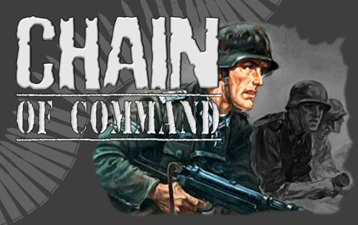
Denmark, April 1940.

Platoon Force Rating. Regular +3.
Platoon HQ
Løjtnant, Senior leader with pistol
Platon Sergent, Senior Leader with rifle

Rifle Grenade Team
1 x Observer (JL) (8mm M.1989/24 rifle)
4 x Rifle grenadiers (4 x 8mm M.1889/24 Rifles + M.1923 Grenade Launchers

3 Rifle Sections
Korporal, Junior Leader with rifle
Grenadier (Grenades + 8mm M.1889/24 rifle
1 x LMG team (Masden M24)
1 x Gunner (9mm M.1910 pistol)
1 x Loader (8mm M.1889/24 rifle)
Rifle team
5 x men (8mm M.1889/24 Rifles)

1 LMG Section
Korporal, Junior Leader with M1889/24 rifle
Grenadier-Grenades + 8mm M1889/24 rifle
1 x LMG team (Masden M24)
1 x Gunner (9mm M.1910 pistol)
1 x Loader (8mm M.1889/24 rifle)
Rifle team
5 x men (8mm M.1889/24 Rifles)
Danish Support List
List One
Satchel Charge
Medical Orderly
Engineer Mine Clearance Team, 3 men
Engineer Wire Cutting Team, 3 men
Engineer Demolition Team, 3 men
Minefield
Barbed Wire
Adjutant
Entrenchments for one Team
Lettet-Forsøgs M41 submachine gun

List Two
Roadblock
Pre‐game barrage
Nimbus MC w/20 mm MG team, 2 Nimbus MC combos,0ne with 20mm autocannon, four Crew including JL.
Tempo Geländwagen 1200 4x4 all terrain Car, no crew

List Three
Madsen M27 tripod MMG with five crew
Sniper Team
Pre‐Game barrage
Bicycle Rifle Section with Junior Leader
Forward Observer Team with 81mm
mortar battery off‐table.
20mm Madsen Anti-Aircraft gun with five crew including Junior Leader.

List Four
37mm Bofors M.1937 Anti-Tank gun with four crew including a Junior Leader
Landsverk M39 Lynx Armoured Car
75mm Krupp 1902 field gun with six crew including Junior Leader
Landsverk L-180 Armoured Car

List Five
Motorcycle Section, four MC combos, 1 20mm Madsen auto-cannon and 2 Madsen LMG. 8 crews including Junior Leader

Danish National characteristics

Madsen M27 MMG teams count as seven dice due to increased stability in the sustained fire role however, being tripod mounted the weapon loses the ability to move and fire. This then provides a reason to use the tripod as they did historically in the game mechanics.
Some support choice most notably the armoured cars have been moved to a higher cost to reflect their rarity.
Bicycle rifle sections are as per normal infantry section strength wise.
Nimbus 20mm section, the second MC combo carries the ammunition and other two crew members.
Koncentreret ild (Concentred fire)
With a strategy based solely for the defence and with limited man-power as a nation the Danish Army placed much emphasis on the accuracy of long‐range musketry as a means of holding an enemy at a distance. To reflect this, a Danish infantry sections firing at Effective range may treat the target as Close range when activated by a Leader using two Command Initiatives.

Fløjte kommandoer (Whistle commands)
With limited communications equipment and a stratergy based on defensive actions Danish leaders made much use of hand signals and whistles to coordiate squad actions. The command range of Danish Leaders is increased by 3 inch when the sections or teams they are commanding are stationary and within line of sight.

