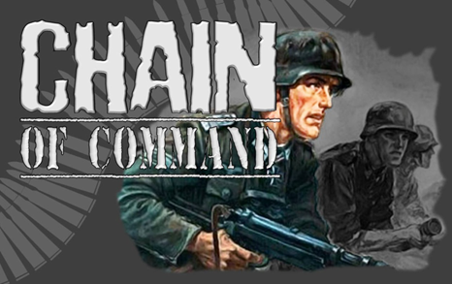

|  |
| --- |
| **Denmark**, April 1940. |

**Platoon Force Rating. Regular +3.**

|  |
| --- |
| **Platoon HQ** |
| Løjtnant, Senior leader with pistol |
| Platon Sergent, Senior Leader with rifle |
|  |

|  |
| --- |
| **Rifle Grenade Team** |
| 1 x Observer (JL) (8mm M.1989/24 rifle) |
| 4 x Rifle grenadiers (4 x 8mm M.1889/24 Rifles + M.1923 Grenade Launchers |

|  |
| --- |
| **3 Rifle Sections** |
| Korporal, Junior Leader with rifle |
| Grenadier (Grenades + 8mm M.1889/24 rifle |
| **1 x LMG team** (Masden M24) |
| 1 x Gunner (9mm M.1910 pistol) |
| 1 x Loader (8mm M.1889/24 rifle) |
| **Rifle team** |
| 5 x men (8mm M.1889/24 Rifles) |

|  |
| --- |
| **1 LMG Section** |
| Korporal, Junior Leader with M1889/24 rifle |
| Grenadier-Grenades + 8mm M1889/24 rifle |
| **1 x LMG team** (Masden M24) |
| 1 x Gunner (9mm M.1910 pistol) |
| 1 x Loader (8mm M.1889/24 rifle) |
| **Rifle team** |
| 5 x men (8mm M.1889/24 Rifles) |
| **Danish Support List** |
| **List One** |
| Satchel Charge |
| Medical Orderly |
| Engineer Mine Clearance *Team*, 3 men |
| Engineer Wire Cutting *Team*, 3 men |
| Engineer Demolition *Team*, 3 men |
| Minefield |
| Barbed Wire |
| Adjutant |
| Entrenchments for one *Team* |
| Lettet-Forsøgs M41 submachine gun |

|  |
| --- |
| **List Two** |
| Roadblock |
| Pre‐game barrage |
| Nimbus MC w/20 mm MG team, 2 Nimbus MC combos,0ne with 20mm autocannon, four Crew including JL. |
| Tempo Geländwagen 1200 4x4 all terrain Car, no crew |

|  |
| --- |
| **List Three** |
| Madsen M27 tripod MMG with five crew |
| Sniper *Team* |
| Pre‐Game barrage |
| Bicycle Rifle Section with Junior Leader |
| Forward Observer Team with 81mm  mortar battery off‐table. |
| 20mm Madsen Anti-Aircraft gun with five crew including Junior Leader. |

|  |
| --- |
| **List Four** |
| 37mm Bofors M.1937 Anti-Tank gun with four crew including a Junior Leader |
| Landsverk M39 Lynx Armoured Car |
| 75mm Krupp 1902 field gun with six crew including Junior Leader |
| Landsverk L-180 Armoured Car |

|  |
| --- |
| **List Five** |
| Motorcycle Section, four MC combos, 1 20mm Madsen auto-cannon and 2 Madsen LMG. 8 crews including Junior Leader |

**Danish National characteristics**

Madsen M27 MMG teams count as seven dice due to increased stability in the sustained fire role however, being tripod mounted the weapon loses the ability to move and fire. This then provides a reason to use the tripod as they did historically in the game mechanics.

Some support choice most notably the armoured cars have been moved to a higher cost to reflect their rarity.

Bicycle rifle sections are as per normal infantry section strength wise.

Nimbus 20mm section, the second MC combo carries the ammunition and other two crew members.

**Koncentreret ild (Concentred fire)**

With a strategy based solely for the defence and with limited man-power as a nation the Danish Army placed much emphasis on the accuracy of long‐range musketry as a means of holding an enemy at a distance. To reflect this, a Danish infantry sections firing at Effective range may treat the target as Close range when activated by a Leader using two Command Initiatives.

**Fløjte kommandoer (Whistle commands)**

With limited communications equipment and a stratergy based on defensive actions Danish leaders made much use of hand signals and whistles to coordiate squad actions. The command range of Danish Leaders is increased by 3 inch when the sections or teams they are commanding are stationary and within line of sight.